**Project name:**

**Blood and Organs Donation System**

**Group members:**

**Salwa Shamma 4010405**

**Samah Shamma 4010403**

**Sana Shamma 4010404**

**Satha Faraj 4010378**

**Section:**

**L01**

**Instructure:**

**Dr. Ftoon Hamza Kedwan**

**Fall 2021**

**Project**

**University of Prince Mugrin**

**College of Computer and Cyber Sciences**

**Computer Science Department**

**CS211**

**CS351**

**Fundamentals of Database Systems**

**Source Code**

**The Blood Bank table:**

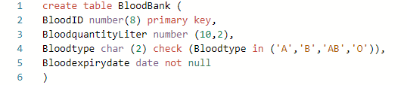

**The Donor table:**

**The Doctor table:**

**The Donatesin table:**

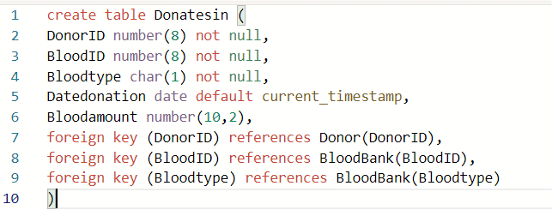

**The Treats table:**

**The Patient table:**

**The orders table:**

**The OrgansInventory table:**

**The Gives table:**

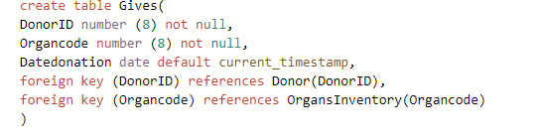

**Insertion Part:**

**The blood bank table**:

**The DonateIN table:**

**The Gives table:**

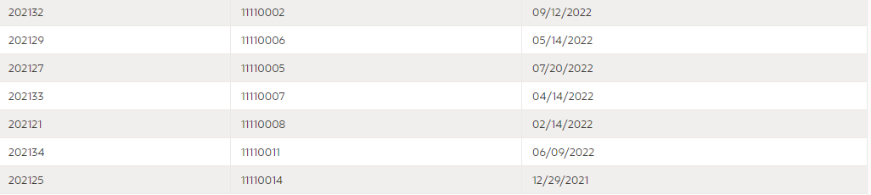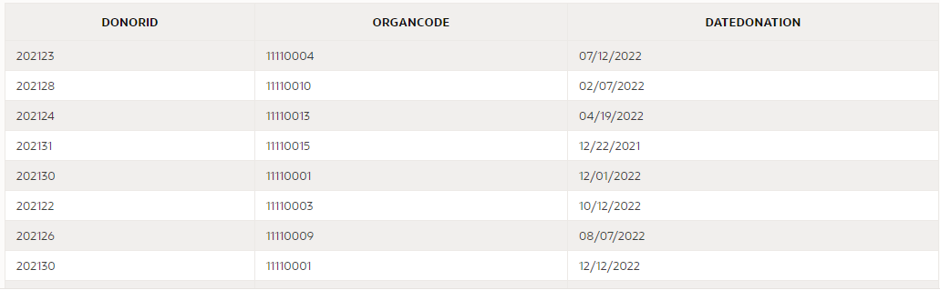

**The patient table:**

**The organ inventory table:**

**The Donor table:**

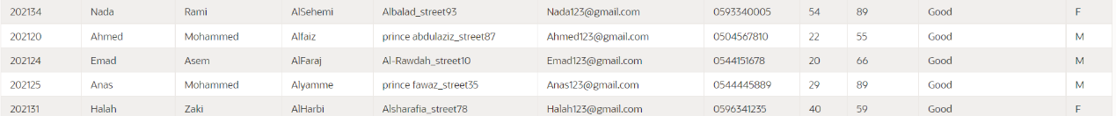

**The Doctor table:**



**The treats table:**

**The orders table:**

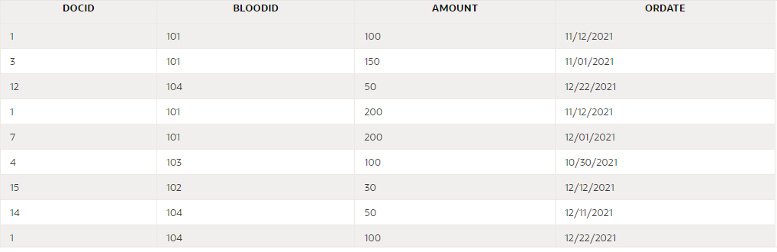

**Queries Part:**

**The blood bank table**

**The DonateIN table**

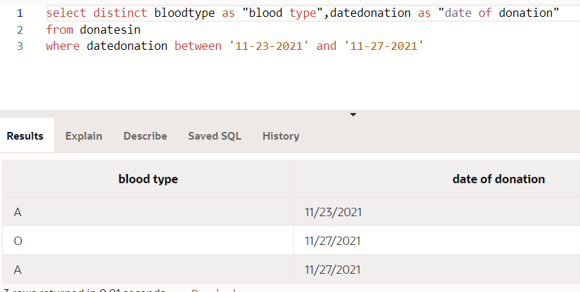

**The Gives table**

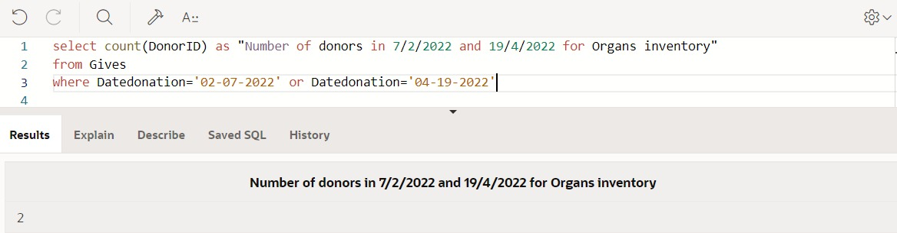

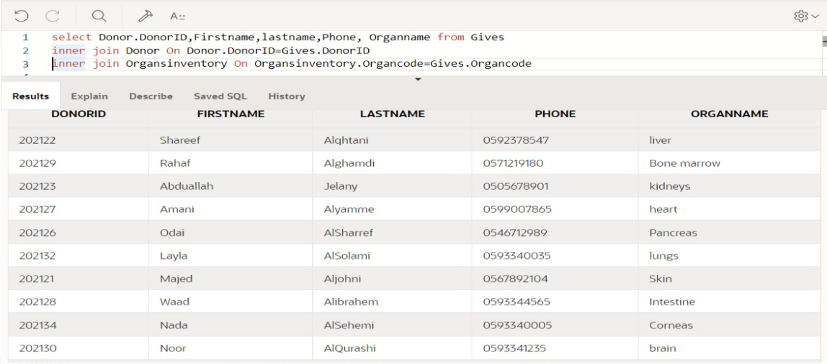

**The patient table**

















**The organ inventory table**





















**The Donor table**

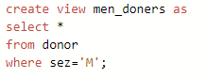

**The Doctor table**

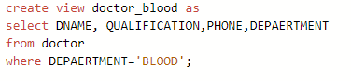

**The treats table**

**The orders table**

Trigger

